cg';"rL–!) s
-lgod *s sf] v08 -s_ ;+u ;DalGwt_
of}ghGo ck/fw ;DalGw zfl//Ls kl/If0f k|ltj]bgsf] 9fFrf
-dlxnfsf] xsdf_
REPORT OF MEDICAL EXAMINATION IN SEXUAL OFFENCE
(FEMALE SUBJECT)
- Case Registration No.:
- Name of the Office referred for examination:
  - Reference number
  - Date
- Name of the accompanying Police Personnel:
DETAIL ABOUT THE EXAMINEE
- Name/ Code Name (To maintain confidentiality):
- Age and Sex:
- Address:
  - Permanent
  - Temporary
- Marital status:
- Guardian′s Name and relation:
- Date and time of examination:
- Attendants Name ⁄ address:
- Identification marks:

- Consent for examination:
- Brief History of the incident, as stated by examinee or guardian

- Medical history:

- Clothes changed or not after incident:
- Whether clothes and body parts washed or not after the incident:
- Description of the examination of clothes:

EXAMINATION
    - General physique and vitals:-
- Height:
- Weight:
- Pulse:
- Temperature:
- Respiratory rate:
- Degree of consciousness:
- Any disability:

    - Injuries on the bodies:
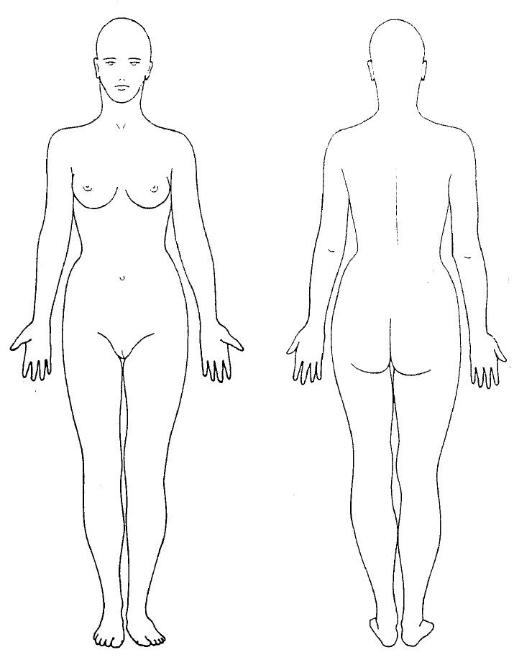
Full Body (Female) – Anterior and Posterior views

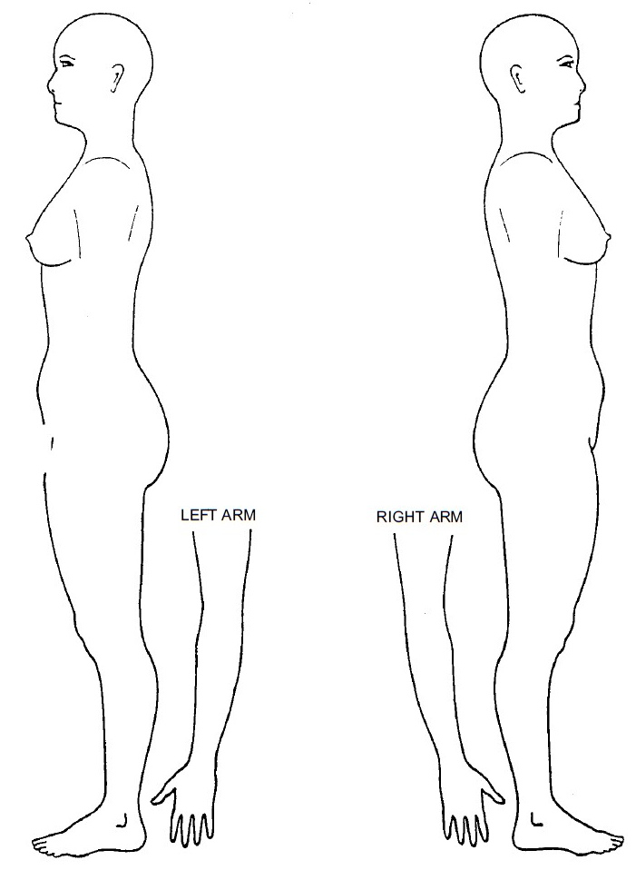 Full Body (Female) – Lateral views

    - Genital injuries
- Perineum:
- Vulva:
- Vagina:
- Hymen:
- Perianal area and anal orifice:
- Oral cavity:
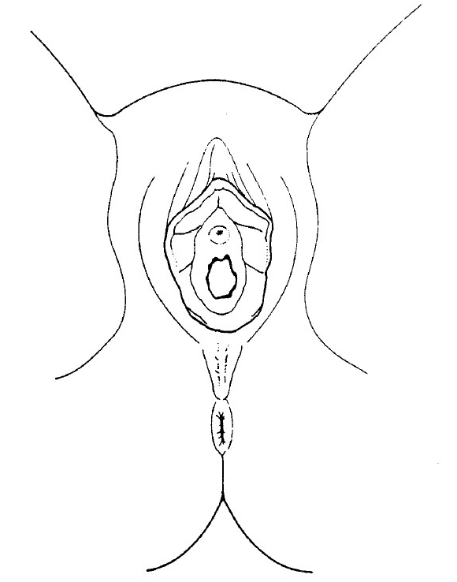

    - Conditions of pubic hair: -

    - Bite marks:-

    - Specimen preserved for further analysis:-
      - Blood:
      - Urine:
      - Swab from stains:
      - Vaginal swab:
      - Foreign hairs debris:
      - Hair from the examinee:
      - Nail scrapings:
    - Investigation and reports:
    - Treatment:
    - Referral:
    - Follow up:
    - Psychiatric evaluation and psychosocial counseling:
    - Condition of teeth
S = ___ Total Teeth (Permanent/Deciduous/Mixed)
Opinion of the expert:
- Opinion about mental status of the examinee:
- Opinion about the injuries on body:
- Opinion about the condition of genital organs:
- Opinion about age of the examinee:
- Other opinion, if any: -
Signature of Medical Officer/Expert:
Name:
Designation:
N.M.C. Reg. No.:
Date:
Seal of the Hospital:

